Business Requirements Document

pull new data table to data platform CR—suggested parts number retail price

**Prepared by: Yanfei Sui**

Version: 01

Aug 14, 2023

Revision History (Mandatory)

|  |  |  |  |
| --- | --- | --- | --- |
| **Version** | **Date of Revision** | **Author of Revision** | **Brief Description of Revision** |
| 01 | 2023.08.14 | Yanfei Sui | Initial CR version for suggested PN retail price pulling |
|  |  |  |  |

Reviewers

|  |  |  |
| --- | --- | --- |
| **Reviewers** | **Representing Area** | **Date of Review** |
|  | *Example: BA / Project Manager / Architect / Technical Leader* |  |
| Yanfei Sui | BA | 2023.08.14 |
| Jinling Zhao | PM | 2023.08.14 |
| Shaopeng Yang | Key user | 2023.08.14 |
|  |  |  |

* *This table is used to track the people who review this document.*

**Table of Contents**

1 Introduction 4

1.1 Project Background 4

1.2 Project Scope 4

1.3 Definitions, Acronyms, and Abbreviations 4

2 Functional Requirements 5

2.1 Affected Functional Areas 5

2.2 Detailed Functional Requirements 5

2.2.1 Indicator List and Definition 5

2.2.2 < Requirements ID: Indicator > 6

2.2.2.1 Define < Table Name > 6

2.2.2.2 Populate < Table Name > 6

2.2.3 < Requirements ID: Indicator > 6

3 Non-functional Requirements 6

3.1 Non-functional Affected Areas 7

3.2 Performance Requirements 7

3.3 Usability Requirements 7

3.4 Security Requirements 7

3.5 Legal Requirements 8

4 Project Impact Considerations 8

4.1 Project Assumptions 8

4.2 Project Constraints 8

4.3 Project Risks 8

5 Appendix 9

# Introduction

## Project Background (mandatory)

* Provide the suggested price as a guidance for price and sales amount calculation
* Easy for next step business analysis for user

## Project Scope (mandatory)

* One new tables added in current product domain data.
* No other function added.

## Definitions, Acronyms, and Abbreviations

The first-time usage of any term, acronym, or abbreviation within this document are defined in the table below.

*Table 1. Definitions, Acronyms, and Abbreviations*

| Term | Definition |
| --- | --- |
| *Example:*  *BRD* | *Business Requirements Document. The document records changes in work activities and work practices, usually including the introduction of the latest information systems and/or services, to help the organization achieve its aims and objectives.* |
|  |  |

# Functional Requirements

This section describes the detailed functional requirements.

## Affected Functional Areas (mandatory)

The following table is a checklist indicating areas that are or are not affected by this project. Note that “Areas” and “Considerations” are not all-inclusive but are meant to elicit dialog between different teams and groups.

*Table 2. Affected Functional Areas*

| Areas | Considerations | Affected (Yes or No) | Manner Affected |
| --- | --- | --- | --- |
| *Product* | *Are changes needed in Product*   * *Product info table with Suggested price and online price variables maintained by business user* |  | New added |
|  |  |  |  |
|  |  |  |  |

## Detailed Functional Requirements

This section documents all detailed requirements.

### Indicator List and Definition (mandatory)

The following table lists all required indicators and corresponding definitions and dimensions that meet business requirements. **If need table change, that goes to Data model change, if not, changes can be implemented in analytic layers (eg: BI report).**

*Table 3. List And Definition of Indicators*

### Data Model (mandatory if need table change)

One new tables need to be added:

dim_prd_product_suggested_retail_price

#### Define < dim_prd_product_suggested_retail_price> (mandatory)

#### The required table structure is as follows:

**Please check Appendix 1 - <Source to Target (Template)>**

**product_suggested_retail_price.xlsx**

#### Populate < dim_prd_product_suggested_retail_price > (mandatory)

If table has many columns, can be attached in the Appendix 1 - <Source to Target (Template)>.

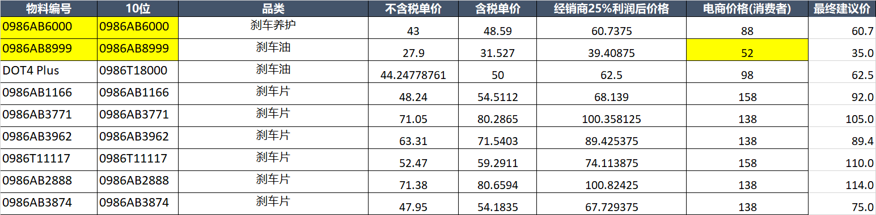

**Please check Appendix 1 - <Source to Target (Template)>**

# Non-functional Requirements

This section addresses non-functional requirements not associated with specific business functions but that must be met for project success.

* Sync with the data source in blob and refresh daily

## Non-functional Affected Areas

The following tables delineate whether or not specific non-functional areas relating to are/are not impacted by the implementation of this project.

*Table 7. Affected Non-functional Considerations*

| Area | Description | Affected (Yes or No) | Manner Affected |
| --- | --- | --- | --- |
| *Data Retention* | *\*\* Consult with Technical Lead and/or Architect* |  |  |
| *System Logging* | *\*\* Note: To be addressed with the Architect* |  |  |
| *Disaster Recovery* | *\*\* Note: To be addressed with the Architect* |  |  |
|  |  |  |  |

## Performance Requirements

Document requirements related to the speed of response, scalability, throughput, execution time and storage capacity.

## Usability Requirements

Document requirements related to the ease of use and understandability of the system for the end-users.

## Security Requirements (mandatory)

This section documents requirements related to the protection of the data from unauthorized access. This includes but is not limited to the followings:

1. Authorization from the data owner is required to access data.
2. Data permission should be assigned based on user roles.
3. Provide a list of data which must be stored or displayed in an encrypted form.
4. The data should be classified, and it is mandatory to review the classification with DSP.

*Table 8. Data Classification*

|  |  |  |  |  |  |
| --- | --- | --- | --- | --- | --- |
| **Business Object** | **Data Fields** | **Personal-related Data**  **(Yes/No)** | **C-SC Security Class** | **I-SC Security**  **Class** | **A-SC**  **Security**  **Class** |
| *parts code* | *Parts_number* | *NO* | *1* | *1* | *1* |
| 10 digi part number | 10_digital_mtrl_num | NO | 1 | 1 | 1 |
| Product category | category | NO | 1 | 1 | 1 |
| Unite price without tax | unite_price_wo_tax | NO | 1 | 1 | 1 |
| Unite price with tax | unite_price_w_tax | NO | 1 | 1 | 1 |
| Dealer price with 25% markup | Dealer_markup_price | NO | 1 | 1 | 1 |
| e-commercial retail price | Ecommercial_price | NO | 1 | 1 | 1 |
| Suggested retail price | Suggested_pricre | NO | 1 | 1 | 1 |

## Legal Requirements (mandatory)

The source and use of data must comply with legal requirements. This includes but is not limited to the followings:

1. Personal Information Protection Law should be obeyed when personal information is involved.
2. Provisions on the Administration of Algorithm Recommendation of Internet Information Services must be abided by, when the requirement includes algorithm recommendation services.

# Project Impact Considerations

## Project Assumptions

The following assumptions have been made for this project:

* <Assumption 1>.
* <Assumption 2>.
* <Assumption Etc.>.

## Project Constraints

The following constraints are associated with the delivery of this project:

* <Constraint 1>.
* <Constraint 2>.
* <Constraint, etc.>.

## Project Risks

The following risks have been identified during this phase of this project:

* <Risk 1>.
* <Risk 2>.
* <Risk, etc.>.

# Appendix

The following documents provide supporting information for this project:

* Appendix 1 - <Source to Target (Template)>



* <Appendix 2> - <Name of Document 2>

<Attached Document 2>

* <Appendix, etc.> - <Name of Document, etc.>

<Attached Document, etc.>